**Exercise-3.1: Printing your machine's name and IPv4 address**

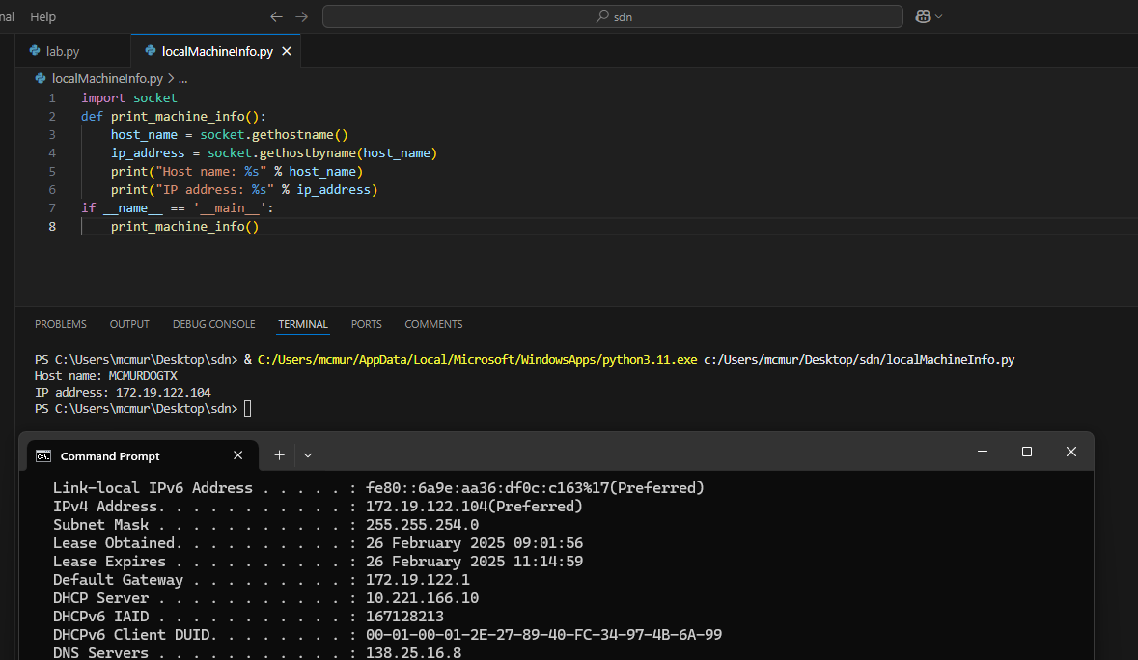

Exercise-3.2: Retrieving a remote machine's IP address

